|  |  |  |  |  |  |  |  |  |
| --- | --- | --- | --- | --- | --- | --- | --- | --- |
|  |  | |  | | |  |  | |
|  |  | |  | | |  |  | |
|  | | | | | | | | |
| http://4.bp.blogspot.com/-SotLIkzmscA/UqQLE9BjdPI/AAAAAAAAARc/-SF46qFfVE0/s1600/daffodil-international-university-logo.png  Object oriented software development | | | | | | | | |
|  | | | | | | | | |
| University Registration System | | | | | | | | |
|  | | NAME:Mehedi Hasan | |  | ID: 151-35-847 | | |  |
| Supervisor Name | | ： | Alamgir kabir | | |
| Department: | | ： | Software Engineering | | |
| Faculty of Science and Information Technology | | | | | |
|  | |  |  | | |
| December 2017 | | | | | | | | |

Table of Contents

Chapter 1 1

1. Introduction 2

1.1 About the System 2

1.2 Purpose 2

1.3 Scope 2

1.4 Vision 2

1.5 Why this system is necessary? 3

1.6 Proposed Solution 3

Chapter 2 4

2. System Analysis 5

2.1 Use Case Model 5

2.2 Actor Goal List 6

2.3 Use Case Description (Brief) 6

2.3.1 Register cours 6

2.3.2 Select course------------------------------------------------------------------ 7

2.3.3 Manage registration-----------------------------------------------------------8

2.4 Use Case Description (Detailed) 9

2.4.1 Register course-----------------------------------------------------------------9

2.4.2 select course--------------------------------------------------------------------10

2.4.3 Manage registration------------------------------------------------------------11

2.5 System Sequence Diagrams ------12

2.5.1 Register course---------------------------------------------------------------12

2.5.2 Select course------------------------------------------------------------------13

2.5.3 Manage Registration-----------------------------------------------------------14

2.6 Domain/Conceptual Model 15

2.7 Activity diagram 16

Chapter 3 17

3. System Design 18

3.1.1 Register course-------------------------------------------------------------------18

3.1.2 select course----------------------------------------------------------------------19

3.1.3 manage registration--------------------------------------------------------------20

3.2 Class Diagram 21

Chapter 4 22

4. Implementation 22

Chapter 1

Introduction

# Introduction

The name of the system is university registration system. A course catalog containing list of course offering. using course catalog student can easily know Information about each course, such as professor, department, and prerequisites. They can select courses or change schedule time. professors also know which course they will be teaching.

## About the System

The university management system. Student can select courses, cancel courses, change schedule time .The professor also select courses, Deselect courses. The register offer courses, assign teacher ,change courses and close registration.

## Purpose

The purpose of the system is student can easily know upcoming semester courses and each courses professor and prerequisites. They can easily register courses ,select courses and changes schedule time also professor knows their teaching courses.

## Scope

It is university registration system which helps the student .They don't need to asked anyone to know upcoming semester courses and teacher. They easily select courses and deselect also change their schedule time. Professor can also know their teaching courses.

## Vision

The vision of the system is to Students can know their courses and professor. They can select the courses and change the schedule time also professor select the courses.

## Why this system is necessary?

The system is necessary for course registration, select course, de-select course ,change schedule, assign teacher ,close registration.

## Proposed Solution

Student can easily select courses, de-select courses, change schedule, assign teacher ,close registration.

# 

Chapter 2

**System Analysis**

# System Analysis

## Use Case Model

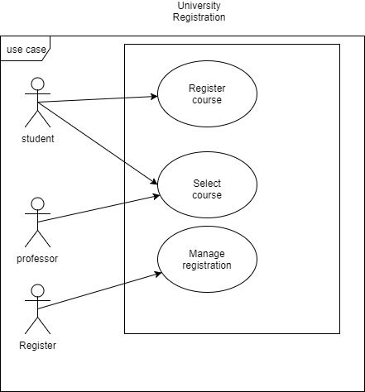

## Actor Goal List

|  |  |
| --- | --- |
| Actor | Goal |
| Student | Student can register courses. They can select the course. They can also change the course. They also change schedule time. |
| professor | Professors can select subject also they can deselect the subject. |
| Register | Register mange registration management. Maintainers the course offer, Assign teacher, change course, cancel course, close registration. |

## Use Case Description (Brief)

### Register course

Student can register courses. They can select the courses. They also change schedule time.

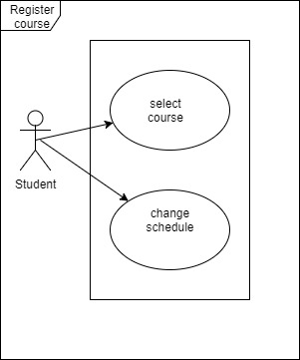

**2.3.2 Select course:**

Student can change the courses and deselect the courses. Teacher can change course also they can deselect the course.

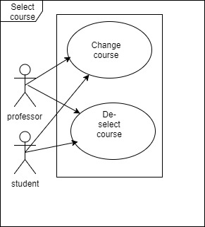

**2.3.3 Manage registration**

Register mange registration management. Maintainers the course offer, Assign teacher, change course , cancel course, close registration.

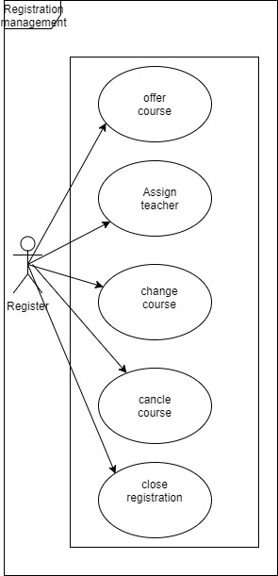

## Use Case Description (Detailed)

**2.4.1 Register course**

|  |  |  |
| --- | --- | --- |
| Use Case Name: | Register course | |
| Scenario : | Student are register courses . | |
| Brief Description: | Student can register courses. They can select the courses. They can also change the courses. They also change schedule time. | |
| Actor: | Student | |
| Precondition: | Must need to login the system. | |
| Post condition: | Register the courses. | |
| Flow of events: | student | System |
| * 1. User must have an account for become a register user or login.   2. select the courses by id   3. change the schedule | * 1. Confirm the valid login   2. Confirm selection   3. Confirm the change |
| Exception Condition: | * 1. If student can't enter the valid user name or password can't enter the system .   2. They enter the system but they enter the wrong course id.   3. They can't change the schedule time. | |

**2.4.2 Select course**

|  |  |  |
| --- | --- | --- |
| Use Case Name: | Select course | |
| Scenario : | Student and professor select or change course. | |
| Brief Description: | Student can change the courses and de-select the courses. Teacher can change course also they can de-select the course. | |
| Actor: | Student, professor | |
| Precondition: | Must need to login the system. | |
| Post condition: | Change course, De-select. | |
| Flow of events: | Student ,professor | System |
| * 1. User must have an account for become a register user or login.   2. Change the courses by id   3. De-selection the course | * 1. Confirm the valid login   2. Confirm change   3. Confirm De-selection. |
| Exception Condition: | * 1. If student and professor can't enter the valid user name or password can't enter the system .   2. They enter the system but they enter the wrong course id.   3. They can't change the courses. | |

**2.4.3: Registration management**

|  |  |  |
| --- | --- | --- |
| Use Case Name: | Registration management | |
| Scenario : | Manage the registration system. | |
| Brief Description: | Register mange registration management. Maintainers the course offer, Assign teacher, change course , cancel course, close registration. | |
| Actor: | Register | |
| Precondition: | Must need to login the system. | |
| Post condition: | course offer, Assign teacher, change course , cancel course, close registration. | |
| Flow of events: | Register | System |
| * 1. User must have an account for become a register user or login.   2. Assign professor   1.9change course by id  1.10 cancel course  1.11 close registration by id | * 1. Confirm the valid login   2. Confirm assign   3. Confirm cancel.   4. conform cancel   5. conform close by id |
| Exception Condition: | * 1. If can't enter the valid user name or password can't enter the system .   2. They enter the system but they enter the wrong course id.   3. They can't cancel curse   4. can't close registration | |

## System Sequence Diagrams

**2.5.1 Register course**

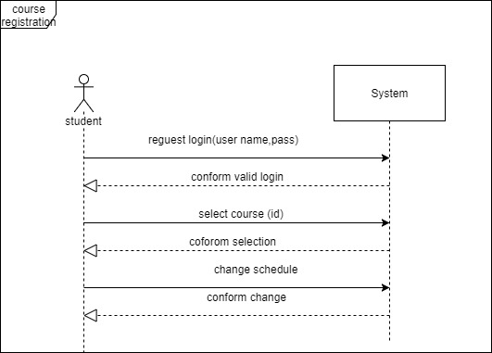

**2.5.2 Select course**

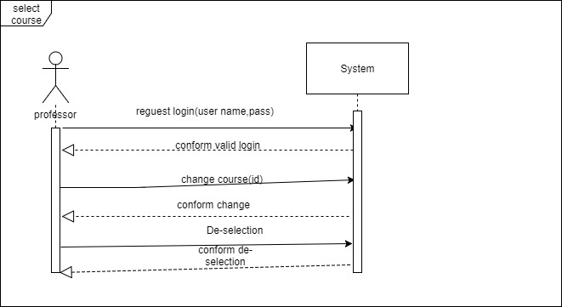

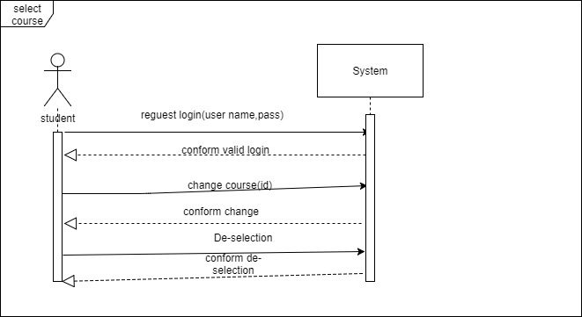

**2.5.3 Manage Registration**

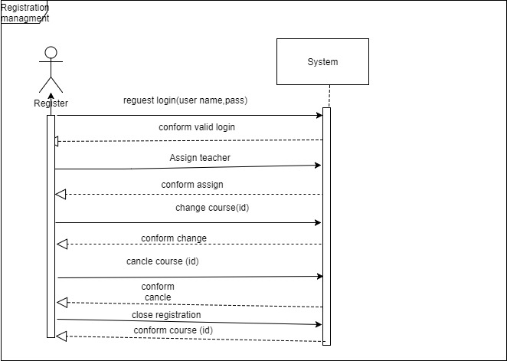

## Domain/Conceptual Model

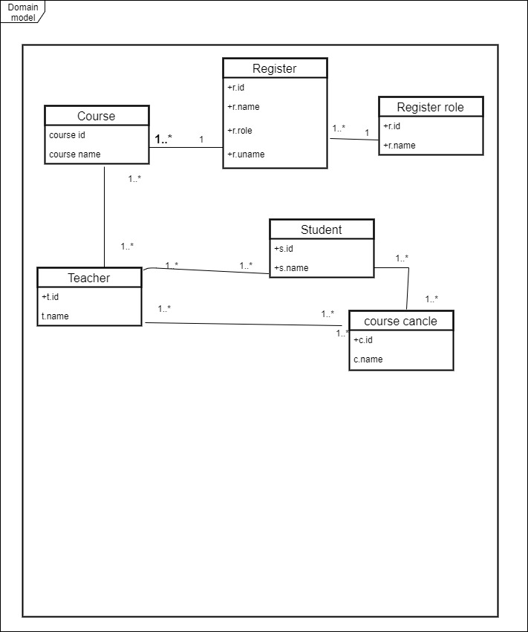

## Activity diagram

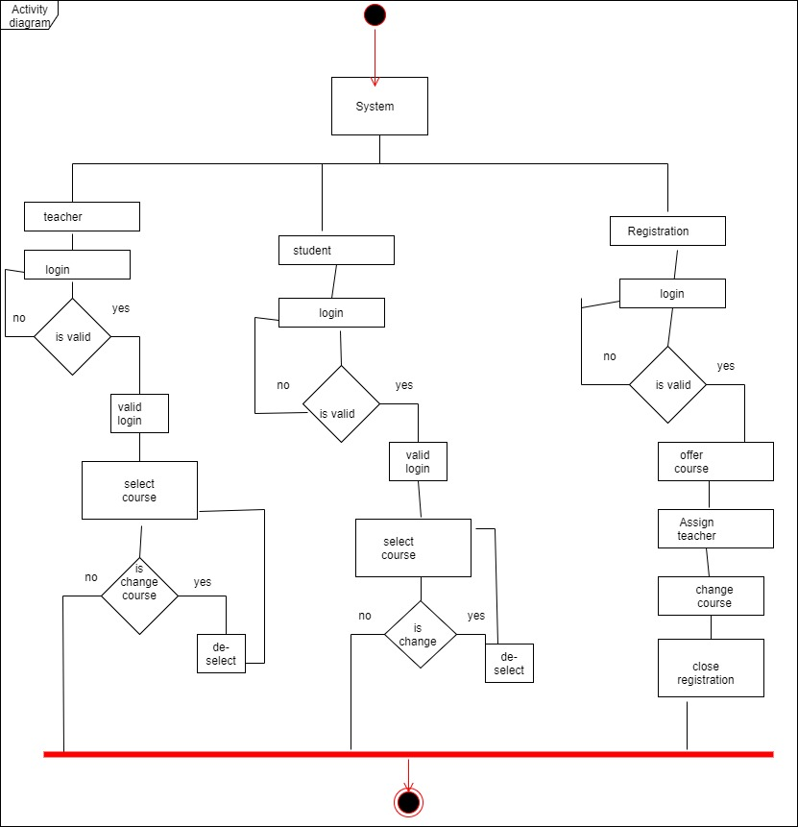

Chapter 3

**System Design**

# System Design

## Sequence Diagrams

**3.1.1 Register course**

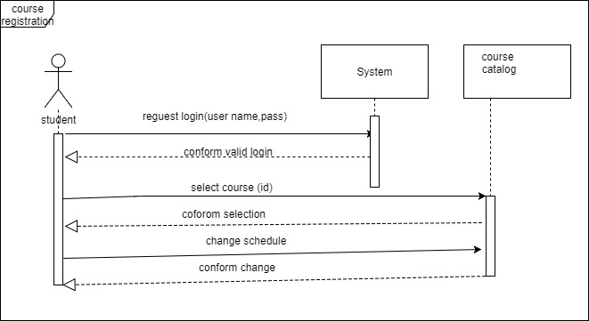

**3.1.2 select course**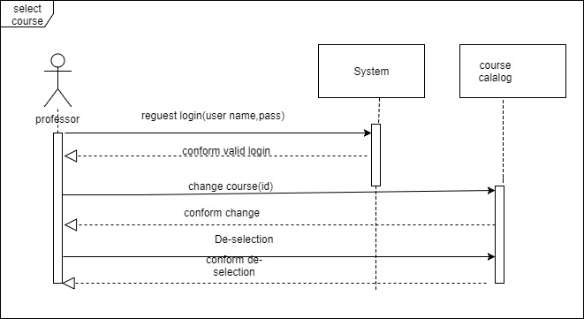

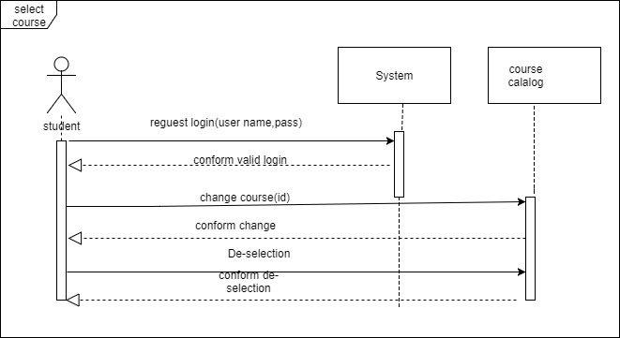

**3.1.3 Manage Registration**

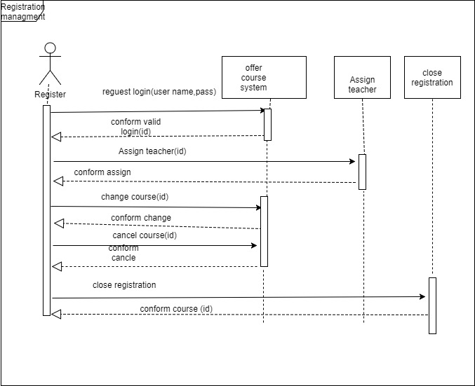

## Class Diagram

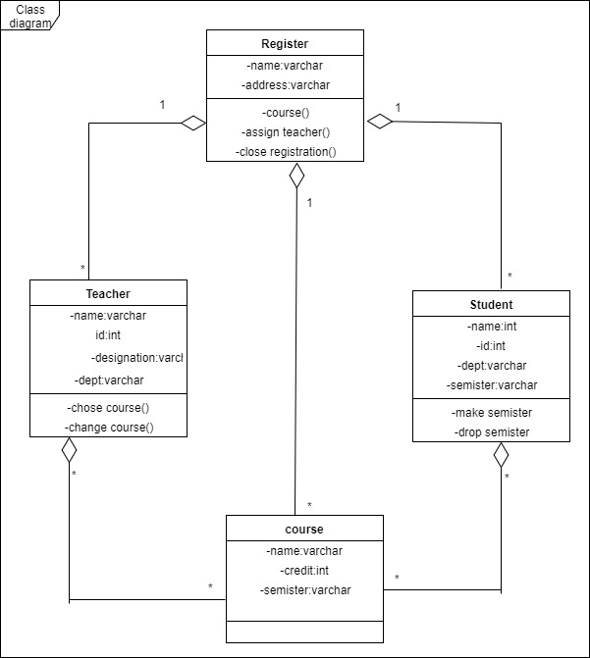

Chapter 4

**Implementation**

# Implementation

**4.1 Tools & Technologies**

For developing this system what tools and technologies will be used are given below:

**Programming Language: PHP**

**Server:** XAMPP